STORYBOARD FOR MY PORTFOLIO

NAME OF THE PROJECT: AGENT NOVERCH

LINKS: index.html, about.html, projects.html

RESOURCES ABOUT EACH PAGE

|  |  |
| --- | --- |
| HOME PAGE |  |
| Background color | #35, 31, 32 |
| Font family | Tahoma |
| Portfolio texts | RGB(FFF), RGB(0, 98, 209), RGB(46, 139, 87) |

UI DESIGNS

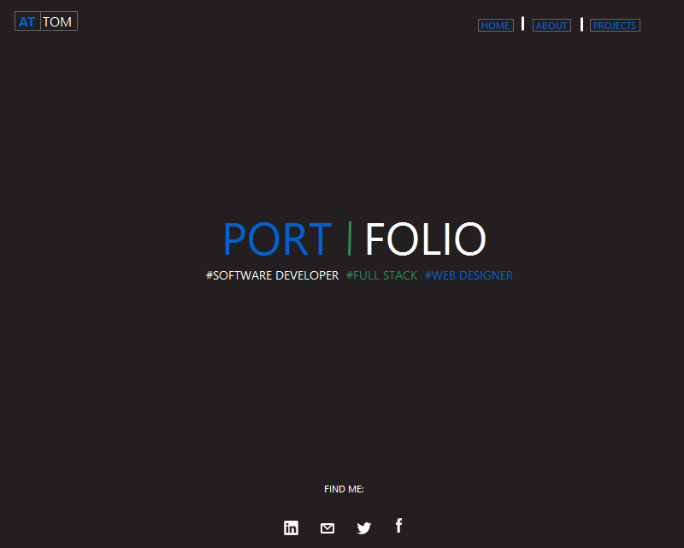

RESOURCES ABOUT EACH PAGE

|  |  |
| --- | --- |
| HOME PAGE |  |
| Background color | #35, 31, 32 |
| Font family | Tahoma |
| Portfolio texts | RGB(FFF), RGB(0, 98, 209), RGB(46, 139, 87) |

UI DESIGNS

